

June 2014
IN THE FRAME

One Foundation Spatial Data Framework making common foundation spatial data ubiquitous across Australia and New Zealand


FSDF Update On 7 April 2014 ANZLIC released the second edition of the Australian and New Zealand Foundation Spatial Data Framework (the Framework), its plan to make common foundation spatial data ubiquitous across Australia and New Zealand.

The Framework is ANZLIC’s principle activity to improve government efficiency, effectiveness and quality of spatial information and service delivery to citizens and the broader economy.

The document completes a body of work defining the current and aspirational states for 36 authoritative datasets organised within ten themes:
Geocoded Addressing
Administrative Boundaries
Positioning
Place Names
Land Parcel and Property
Imagery
Transport
Water
Elevation and Depth
Land Cover

ANZLIC has four areas of focus for the evolution of datasets within the themes, shown in the figure below.
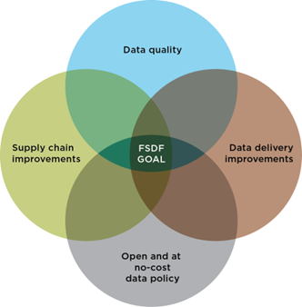
Further information on the FSDF is available at the ANZLIC website, http://www.anzlic.gov.au/

Industry Engagement To assist in the delivery of the FSDF, an Industry Advisory Committee is being established to coordinate information between industry producers and users of spatial data. This committee will comprise industry bodies, jurisdictional representatives, eminent individuals from the spatial community and also the FSDF Project Management Committee.

The first task of the Industry Advisory Committee is to arrange a series of outreach sessions across Australia and New Zealand to gather feedback on the implementation of the FSDF.

Potential industry involvement is not limited to the Advisory Committee. Members from industry are welcome to join in with the Theme Leadership Groups to assist in the technical development and data improvement programs, effectively shaping the future direction of the national spatial data infrastructure.

A good example of this collaboration is the relationship that companies like Nokia, Sensis and Intelematics Australia have with the Transport Theme in developing use cases and the future needs of the national surface transportation network. If you need further detail on the activities of the Industry Advisory Committee please contact Alan Smart, Director SIBA AU or the FSDF Secretariat at spatial@communications.gov.au.

FUTURE ACTIVITIES
June–October 2014 Industry briefings in conjunction with SIBA



11-13 July 2014
FSDF datasets will be tested at GovHack 2014

14 August 2014
Theme three-year plans to be considered at the ANZLIC meeting

6-7 November 2014
2015 Roadmap for dataset improvements considered at the ANZLIC meeting

